**Student name**_______________________

Date issued _____________ Due End Oct / Early Nov 2012

**Rangiora Rebuild-The long Term Plan**

**Situation:**

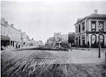Rangiora business, commercial and residential sectors have been affected by the earthquakes and aftershocks in the same way as Christchurch CBD. The scale may be smaller but the devastation is felt here just as much. This natural disaster, presents you with an opportunity to develop and transform Rangiora into a township ***more appropriate for the expectations of the 21st century***

We may have seen the new ‘pop-up’ centre in Christchurch-Cashel Mall, and how successful it has been in bringing life and business back to the central city. This is a short term ‘fix’, and this is the focus of the Year 11 DVC course.

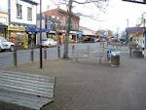Starting points….

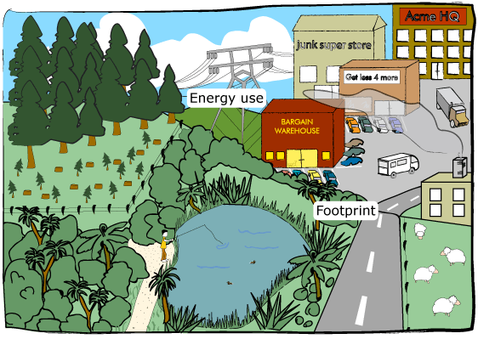When you think of Rangiora, what images come to mind?

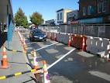

These images are what make the identity of other towns/cities.

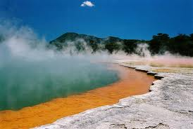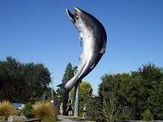



What could be Rangiora’s ‘identity symbol’ to enable a successful rebuild?

* ***sculpture***-Rakaia’s fish
* ***park***-New York’s Central Park
* ***Unique building***-Christchurch’s Cathedral, New York’s Empire State Building, World Trade Centre
* ***man-made*** ***attraction***-Hanmer Thermal Pools, Zoo’s, Rainbow’s End/Gold Coast
* ***natural resources or attractions***-Niagra Falls/Rotorua’s hot pools, Coal/Gold on the West Coast, Oil in Iran, Diamonds in South Africa, Iron Ore in Australia
* ***celebrity/food*** attraction-café-Seagars in Oxford, Cornish Pasties, NZ’s Pavlova
* ***sustainable transport systems***-Manchester’s Trams
* ***unique activities***-Queenstown, bungee jumping, shotover jets, frisbee golf
* ***home of a rare animal***-Kiwi’s, Kia’s, Canadian bears
* ***production of iconic product***-TVR cars Blackpool
* ***historical event/place of cultural significance***-Mecca pilgrimage for Muslims, Anzac-battle ground
* ***Unique architecture****-* Dunedin’s Gothic style, Napier’s Art Deco
* ***Integrated and successful town plan-bringing this altogether? A tough one!***- business, retail, markets-indoor and outdoor, leisure facilities, green areas, amenities-council buildings, WC’s, sustainable transport and ease of access, range of accommodation-small flats, family homes

**Brief:**

Research, develop and design to a **conceptual model stage** either;

1) A **set of plans** for a ‘21st century’ Rangiora Town plan



2) An **identity icon** based upon Rangiora’s unique character and location

### Special notes:

* The town plan project *can* be completed in pairs or small groups. Be very careful if you elect to do this-remember this is a ‘yearlong’ project and team dynamics could enhance or ruin your year of learning
* The identity icon project would be better completed individually
* [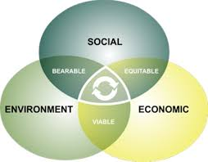](http://www.google.co.nz/imgres?q=sustainability&hl=en&sa=X&qscrl=1&nord=1&rlz=1T4ADRA_enNZ417NZ420&biw=1280&bih=521&tbm=isch&prmd=imvnslb&tbnid=mLliaqj1eKQrgM:&imgrefurl=http://drsuneelsethi.wordpress.com/2011/02/20/communicating-the-%E2%80%9Csustainability%E2%80%9D-message/&docid=wMr_FCT03_7F1M&imgurl=http://drsuneelsethi.files.wordpress.com/2011/02/sustainability_graphic.jpg&w=380&h=296&ei=y_RCT8fdKMe3iQeF5dXNBA&zoom=1)Locate and identify *a number of* suitable stakeholders to guide you
* The Waimakariri District Council is working in collaboration with Rangiora High School at Level 1, 2 & 3 for this project. There is a possibility your ideas could become part of the town’s future development
* You will be presenting your thinking at two key stages 1st-when the concept has been fully developed (approx. end term 2), 2nd when the conceptual model and supporting visuals are complete (approx. end term 3)
* You can use a combination of ICT based visuals or hand drawn, or entirely one or the other. (please refer to NZQA requirements for digital submissions)
* Assessment is based around the Technology matrix generic standards 2.1-2.13, and DVC specialist standards 2.30-2.36. You should become familiar with these and during the course of the project, consult with your teacher and caregivers, and decide which standards will fit best with your personal interest, skill level and NCEA plans.
* Useful resources at [www.rtc2020.co.nz](http://www.rtc2020.co.nz) reports and updates are very useful, and also an email update is available.

**Specifications**

**The outcome must:**

* be fit for purpose
* provide a unique identity for the town (refer to earlier architect study)
* meet the needs of a range of community groups
* be developed in collaboration with carefully selected and relevant stakeholders
* meet the life cycle considerations-DfD (Design for Dis-assembly)
* be sustainable for the 21st century-this means the outcome demonstrates responsible management of resources to support the capacity to endure within environmental, social, and economic dimensions
* [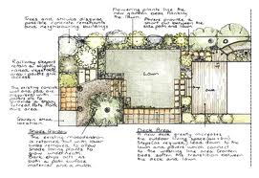](http://www.google.co.nz/imgres?q=planning&hl=en&sa=X&rlz=1W1ADRA_enNZ417&biw=1280&bih=521&tbm=isch&prmd=imvnsb&tbnid=S6nlTTLHyuBXwM:&imgrefurl=http://www.shelleygroves.co.nz/how-i-work/&docid=bqRbn9J5jjtoeM&imgurl=http://www.shelleygroves.co.nz/how-i-work/img/plan-02.gif&w=412&h=283&ei=RPNCT-qrAs2iiAf7hemCBA&zoom=1) (Student to add specifications to this list as need and stakeholder dictate.)

[](http://www.google.co.nz/imgres?q=sustainability&hl=en&sa=X&qscrl=1&nord=1&rlz=1T4ADRA_enNZ417NZ420&biw=1280&bih=521&tbm=isch&prmd=imvnslb&tbnid=D1I-RF0uJYNIuM:&imgrefurl=http://eventsforchange.wordpress.com/2011/04/28/why-sustainability-is-not-%E2%80%9Cgood%E2%80%9D/&docid=XeWiHfKAlGeYHM&imgurl=http://eventsforchange.files.wordpress.com/2011/04/aint_easy_being_green.jpg&w=347&h=450&ei=y_RCT8fdKMe3iQeF5dXNBA&zoom=1)***Student guidelines/instructions***

1. Investigate and **identify** (N/A) the work of a New Zealand based or world-wide architect. Present a visual overview of their work and discuss how they may have influence over your outcome. Include as the opening sheets and the base research to your communication portfolio.

**Describe** (Ach) and ***analyse*** the considerations which contribute to ‘Life-cycle’ and decide the focus for design interventions which are evident in their work and contribute to the quality of the design (refer **2.10** NZQA AS for definitions).

Describe and Explain the relationship between lifecycle design, innovation and sustainability

**Explain** (Merit) how the *Life-cycle considerations impact on the sustainability* of the design Explain how lifecycle analysis is undertaken and how this determines the focus for design intervention. Explain how issues identified by lifecycle analysis led to design innovation being applied in the development of a sustainable technological outcome.

**Explore** (Exc.)Discuss the competing priorities-what is important and comes first- and compromises-what can be put aside- made as a result of lifecycle analysis in the development of a sustainable technological outcome.

**HINT** Refer to 2.10 supporting notes-DfD (Design for Dis-assembly) analysis.

1. Write a personal statement that specifies the requirements for the brief, including reference to at least 2 of each- societal, economic and environmental priorities you will consider. Explain and justify the inclusion of these considerations in your design.
2. Your solution must conform to the concept of your life cycle analysis and how the decisions made after this contribute to a *sustainable outcome*



1. Research, and present (digitally or on A3 paper) and evaluate in detail (refer to literacy guide sheet & point 3 above) a range of existing solutions from online, consultations or other sources that show:

* how an outcome is fit for purpose
* how it provides a unique identity for its location
* how it meets the needs of the community
* how is has been designed-or not with sustainability considerations

Your evaluation should include notes that refer to the points above and identified earlier during the architectural study, and the features and benefits of any existing solutions you see relevant from your research. You should include a commentary or quick freehand sketches stipulating some ideas that you could use/develop further, and which will have a positive impact on the quality of the overall fitness for purpose, design aesthetic and function.

1. With **reference to your research (state clearly visually, which bits came from where)**,

a) Generate a series of freehand concept ideas, both 2-D and 3-D, showing a range of options for overall solution. Use annotation to clarify these ideas-refer to specifications which ones are met.

b) Add rendering with tonal change, to the concepts (or parts of concepts), and shadow to provide reality and situation, which will effectively communicate and visualise your thinking to the audience.

1. Evaluate these ideas with regard to the design specifications including the two societal, economic, and environmental considerations. Whilst completing the evaluation, make reference to the life cycle analysis and how this could enable a sustainable outcome. You may comment on how patterns, style, lines etc can affect the overall impression.
2. Produce a series of 3D sketches, using instrumental paraline drawing techniques; isometric and oblique that will generate and clarify design detail. This can include cut-away views of parts to communicate depth.

Evaluate these sketches using design language, against the specifications.

1. Indicate where you have made reference to the life cycle and sustainability of the development in your solution and provide clear evidence of on-going evaluation particularly between each stage of the solution’s development. Decisions made throughout this design process need to be justified and evaluated as to their impact on the outcome’s quality. The stakeholders considerations have to be shown (what they are and how you have achieved them) throughout this stage of the Technological process.

1. Produce to scale, using the relevant drawing standards hand-drawn or ICT produced (NZ/AS 1100), 3rd angle orthographic, instrumental drawings of the:

* final outcome in whole and as key components



**PLUS**

instrumental pictorial views of any significant component/s

instrumental pictorial view of the outcome in situ

[](http://www.google.co.nz/imgres?q=sustainability&hl=en&sa=X&qscrl=1&nord=1&rlz=1T4ADRA_enNZ417NZ420&biw=1280&bih=521&tbm=isch&prmd=imvnslb&tbnid=IKuUsfjtMmZ_kM:&imgrefurl=http://justincaseyouwerewondering.com/2011/10/24/sustainability/&docid=qUZ-cHdAlcQ0sM&imgurl=http://justincaseyouwerewondering.com/wp-content/uploads/2011/10/sustainability.jpg&w=308&h=307&ei=y_RCT8fdKMe3iQeF5dXNBA&zoom=1)***This stage is expected to be completed by end term 2. At this point there will be a first, initial presentation to the WDC where feedback on solutions will be given***

10. Evaluate your final solution in terms of the specifications, stakeholder consultations and your thinking compared with before this project started.

11. Produce a scale model of the outcome. This can be either;

- a 3D physical model of a part or whole

- a 3D digital model which will enable the client a ‘virtual’ journey of the outcome

Bringing it all together:

* Prepare a presentation of your communication portfolio and model (digital or on paper) **in a manner that will be presented to the Waimakariri District Council**. **Hint** Use of the NO CRAP composition principles to effectively visually communicate your design thinking and solutions to the issue presented will ensure clarity and focus for the audience.

***This stage is expected to be completed by end term 3***

12. Complete a report to conclude 2.10 achievement standard. This will be a reflection of how the sustainability of a design is determined using life cycle analysis, and how this has informed your outcome to meet the brief of a 21st century solution. (Refer NZQA pdf doc AS91363 Assessment Specifications) ***This is Term 4’s activity***

**Reminder:** Record details of all time spent on this work. You should aim to be thinking of this as a commercial venture (you get paid for your time) and therefore is a very important aspect. This year is all about BEING a successful designer, not just practicing! What you produce is and could become a reality. Good luck, and be brave and adventerous!

Develop your ideas, using sketches and notes, to reach a solution that meets the requirements of the brief. Evaluate these ideas with regard to the design specifications, societal, economic and environmental considerations, life cycle and sustainability of design outcomes.

Att: AS2.10, Supporting notes, AS91363 Assessment Spec. DVC21 Moodle course page-all resources

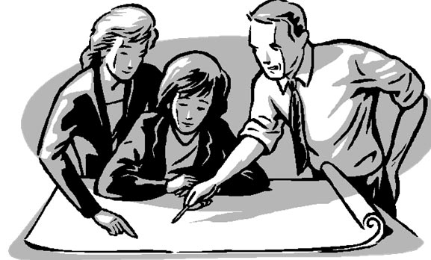

Well that went well – NOT!



sustainability